Full name

Gender:
Marital status:
Date of Birth
Total experience
Knowledge Language:
Knowledge of the game:

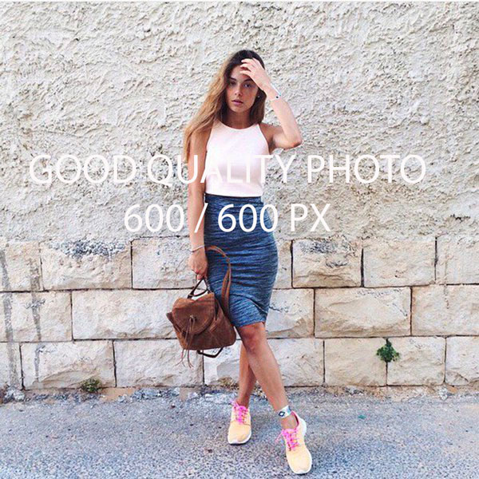

Full name
Email: | staff.iliper@gmail.com
Citizenship: | Russia
Address: | Moscow, Tverskaya 55, apar.73
WhatsApp: | +380 95 3717478
Facebook: | https://www.facebook.com/iliper.iliper.10

EXPERIENCE

Name of casino/Country | years | position
Name of casino/Country | years | position
Name of casino/Country | years | position
Name of casino/Country | years | position
Name of casino/Country | years | position
Name of casino/Country | years | position

WHO CAN RECOMMEND

Full name of the person to contact:
Email:
WhatsApp:

